VOCABULARY
1 Circle six travel words in the puzzle. Then write the words next to the clues.
p | n | a | r | r | i | v | a | l | d
a | a | d | g | p | m | n | q | x | e
s | y | s | z | c | e | y | t | o | p
s | a | v | s | g | h | f | n | l | a
p | z | x | v | e | q | l | e | i | r
o | w | c | i | f | n | i | y | g | t
r | i | u | m | s | a | g | b | j | u
t | j | k | t | r | b | h | e | l | r
q | d | h | s | e | c | t | f | r | e
1 You need this document when you travel to other countries. ..... ..... ..... ..... ..... ..... ..... .....
2 the act of leaving a place ..... ..... ..... ..... ..... ..... ..... ..... .....
3 the act of coming to a place ..... ..... ..... ..... ..... ..... .....
4 a traveller in a vehicle ..... ..... ..... ..... ..... ..... ..... ..... .....
5 You sit there on an aeroplane. ..... ..... ..... .....
6 a journey on an aeroplane ..... ..... ..... ..... ..... .....
2 Choose the correct answer.
1 Arrival / Flight / Departure is in 20 minutes. We must get on the aeroplane.
2 You look tired – you should take a break / go to the information desk / make reservations.
3 Did you go to the ticket office / book a room / check the luggage allowance at the hotel for our holiday?
4 My sister is travelling by land / by sea / by air across Europe because she loves train journeys.
5 Before there were aeroplanes, people travelled to America by flight / making reservations / sea.
3 Complete the sentences with the words below.
ticket office  luggage allowance  information desk
made reservations  by air
1 Go to the ................................................................. and ask where the café is.
2 Go to the ................................................................. before you get on the train.
3 I can’t take much because the ................................................................. is 20 kg.
4 My dad ................................................................. at a nice restaurant.
5 More people are travelling ................................................................. because flights are much cheaper now.
grammar
4 Complete the sentences with the verbs below. Use the Past Continuous.
make  not watch  take  not sit  not wear  travel
1 The actor .............................................. a vampire costume an hour ago.
2 I .............................................. through the tunnel at 8.00 pm.
3 We .............................................. a horror film on TV last night.
4 They .............................................. reservations for the tour of Chernobyl at 10.00.
5 The tourist .............................................. pictures of the cemetery a minute ago.
6 The passengers .............................................. in their seats at 6.00.
5 Complete the text with the verbs in brackets. Use the correct form of the Past Continuous.

Hi, Janet!
What ^{1.} .............................................. you (do) at 11.00
Saturday morning? I ^{2.} .............................................. (scream) ! No, I ^{3.} .............................................. (not have) another fight with my brother. My friend and I ^{4.} .............................................. (visit) Thorpe Park, an amusement park in England. It happened at the Walking Dead ride, a recreation of the Walking Dead world from a TV show about a zombie attack. While we ^{5.} .............................................. (wait) to go into the attraction, actors in zombie costumes ^{6.} .............................................. (try) to frighten us. Soon, we ^{7.} .............................................. (walk) down a dark tunnel towards
the ride, with zombies all around us. I don’t like
surprises, so I ^{8.} .............................................. (not feel) very comfortable. By end of the ride, I ^{9.} .............................................. (shake) with fear.
Amy
6 Write questions with the words below. Use the Past Continuous. Then answer the questions
about yourself.
1 you / sleep / at midnight

2 what / the students in your class / study / at 11.30

3 you / check / your messages / a minute ago

4 your friends / exercise / at 9.00

VOCABULARY
1 Circle the word that doesn’t belong.
1 attack: a person • an arrow • a prisoner
2 capture: a murderer • a thief • a judge
3 escape: from an expert • from prison from the crime scene
4 break into: a shop • a house • a jury
2 Complete the sentences with the words below.
arrows  case  punished  crime scene  innocent  victims
1 His parents .............................................. him for behaving badly.
2 The museum has got many historic Native American .............................................. .
3 Doctors examine the bodies of .............................................. .
4 When the detective arrived at the .............................................. , he saw blood everywhere.
5 After working on the .............................................. for years, the detectives finally solved it.
6 The woman was .............................................. , so she didn’t go to prison.
3 Complete the words in the questions in A. Then match the questions to the answers in B.
A
1 Who defends a person in c ..... ..... ..... ..... ?
2 What group of people decides who is g ..... ..... ..... ..... ..... ?
3 Who does a m ..... ..... ..... ..... ..... ..... ..... kill?
4 What does a t ..... ..... ..... ..... sometimes hold to scare people?
5 What does a j ..... ..... ..... ..... do?
B
..... a a victim
..... b punishes criminals
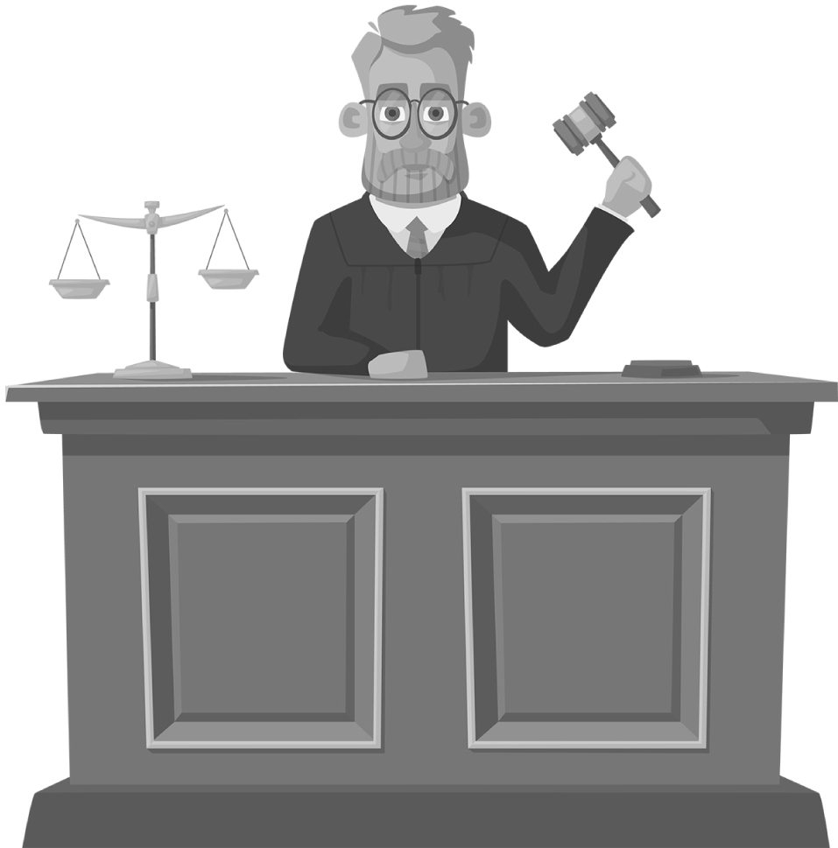
..... c a jury
..... d a lawyer
..... e a gun
3
grammar
4 Complete the sentences with the verbs in brackets. Use the Past Simple or the
Past Continuous.
1 He .............................................. (not watch) the news when they .............................................. (announce) the murder.
2 While they .............................................. (examine) the crime scene, they .............................................. (find) the murder weapon.
3 When the thief .............................................. (break into) the house, the owners .............................................. (sleep).
4 I .............................................. (describe) the thief when he suddenly .............................................. (approach) us.
5 When the reporters .............................................. (arrive), the police .............................................. (interview) people in the crowd.
5 Complete the text with the verbs in brackets. Use the Past Simple or the
Past Continuous.
It was the summer of 2008. Anthony Curcio ^{1.} .............................................. (watch) the Bank of America building
when a van ^{2.} .............................................. (bring) money to the bank. Curcio ^{3.} .............................................. (write) the
delivery time while he ^{4.} .............................................. (observe) the delivery. Curcio continued watching the bank
for three months. Then he advertised for workers for a fictitious cleaning job and told them what to wear.
When the workers ^{5.} .............................................. (come) to work on 30th September, Curcio ^{6.} .............................................. (wear)
the same clothes. While the workers ^{7.} .............................................. (clean), Curcio went to the bank car park, attacked
the security guard and stole the money. When the police arrived, witnesses described the thief’s clothing.
The cleaners ^{8.} .............................................. (still / work) near the bank, and they had the same clothing. But Curcio,
the real thief, wasn’t there. The police captured him only six months later.
6 Write questions with the words below. Use the Past Simple or the Past Continuous.
Then answer the questions about the text in Exercise 5.
1 what / Curcio / see / while / he / watch / the bank

2 what / he / do / while / he / watch / the van

3 what / Curcio / do / while / the workers / clean

4 where / the cleaners / work / when / the police / arrive

