VOCABULARY
1 Choose the correct answer.
1 There’s a river at the bottom of the planet / grass / canyon.
2 There are tropical birds in the rock / rainforest / ground.
3 Can you see those birds flying in the moon / sky / ground?
4 In the desert, you can see millions of stars / fields / moons at night.
2 Complete the sentences with the words below.
planet  field  moon  rock  jungle
1 Jupiter is a .............................................. in the universe.
2 Can you see the .............................................. when the sky is very cloudy?
3 There are vegetables growing in the .............................................. .
4 The .............................................. is a tropical forest.
5 Careful! There’s a snake under that .............................................. !
3 Complete the text according to the picture.
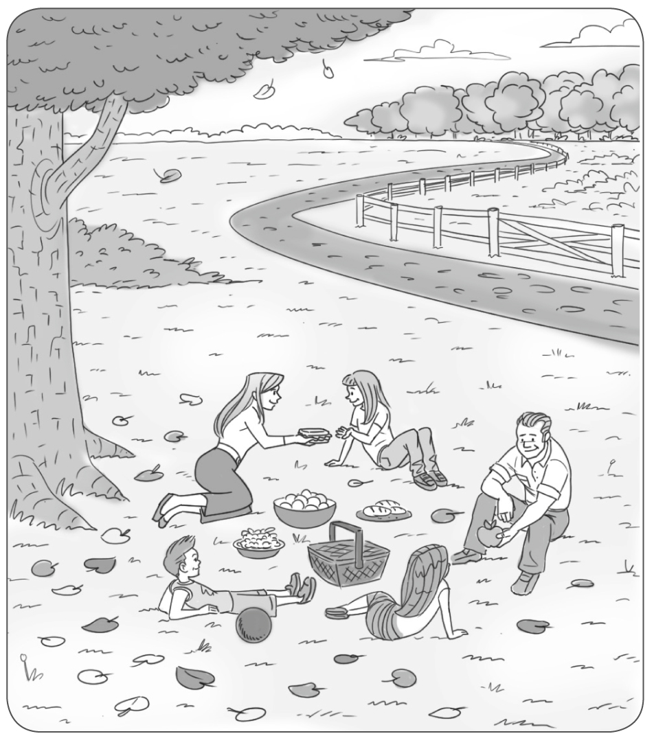
The family is having a picnic in the ^{1.} c..............................................e. They are sitting on the ^{2.} g..............................................s under a big
^{3.} t.............................................. . There are many ^{4.} l..............................................s on the ^{5.} g..............................................d. There is a long
^{6.} p.............................................. going into the forest.

grammar
4 Complete the sentences with the verbs in brackets. Use the Past Continuous affirmative.
1 Rose and Mandy ................................................................ (learn) about the planets at 11.00.
2 Bill ................................................................ (stand) under the tree five minutes ago.
3 I ................................................................ (watch) a documentary about the Grand Canyon at 8.30.
4 We ................................................................ (hike) in the rainforest during the month of August.
5 Julia ................................................................ (study) for a maths test at 7.00 last night.
5 Complete the sentences with the verbs below. Use the Past Continuous affirmative.
look  rain  sit  have  explore
1 We ................................................................ a picnic in the countryside at 1.00 in the afternoon.
2 I ................................................................ in the classroom at 8.30 yesterday morning.
3 Pete and Rebecca ................................................................ at the stars at 11.00 last night.
4 Bob ................................................................ the jungle during the month of October.
5 It ................................................................ all afternoon yesterday.
6 Complete the text with the verbs in brackets. Use the Past Continuous.
On 21st August, 2017, I ^{1.} ................................................................ (visit) Jackson Hole, Wyoming, in the USA. It was a beautiful day. Thousands of people ^{2.} ................................................................ (wait) for the solar eclipse. The last solar eclipse in the USA was in 1979, so everyone ^{3.} ................................................................ (feel) excited about this rare experience. We ^{4.} ................................................................ (wear) special glasses to protect our eyes during the eclipse. At about 10.15, the moon ^{5.} ................................................................ (begin) to cover the sun. It took one hour and 18 minutes for the total eclipse to happen. It ^{6.} ................................................................ (get) cold and dark. People ^{7.} ................................................................ (put on) their coats and sweaters. Animals ^{8.} ................................................................ (make) noise because they didn’t understand why it was so dark in the middle of the day. At about 11.35, the moon was on top of the sun completely. Then suddenly, the eclipse ended, and the sun appeared again.

VOCABULARY
1 Choose the correct answer to show you understand the words in bold.
1 The little girl climbed up the … .
a field b tree c sky
2 We really enjoyed the … .
a show b jeep c bridge
3 We all laughed when we heard the … .
a funny story b angry shouts c beautiful song
4 I made a mistake … .
a in the ground b in the test c in the dictionary
5 The baby is crying because it’s … .
a hungry b happy c quiet
6 The police didn’t believe the man’s … .
a picture b laptop c story
2 The words in bold are in the wrong sentences. Write them next to the correct sentences.
1 Adam remembered his phone and it broke. ..............................................
2 When she suggested, I knew everything was OK. ..............................................
3 He dropped what happened that day. ..............................................
4 I ran towards my gloves, so I bought new ones. ..............................................
5 Eve smiled a visit to the Natural History Museum next weekend. ..............................................
6 My dog lost me happily. ..............................................
3
grammar
3 Complete the sentences with the verbs in brackets. Use the Past Continuous negative.
1 They ................................................................ (walk) in the countryside at 4.00 in the afternoon.
2 I ................................................................ (travel) in the rainforest in August.
3 The children ................................................................ (play) a game at 9.00 last night.
4 The cats ................................................................ (climb up) the tree several minutes ago.
5 My brother ................................................................ (enjoy) the TV programme.
4 Write questions with the words below. Use the Past Continuous.
1 where / Mandy and her father / go

2 the baby / cry / last night

3 Fred / run towards / his mother

4 Wendy and Carly / laugh / during the show

5 Nick and Dan / smile / in the photo

5 Look at the pictures. Answer the questions from Exercise 4 according to the pictures.
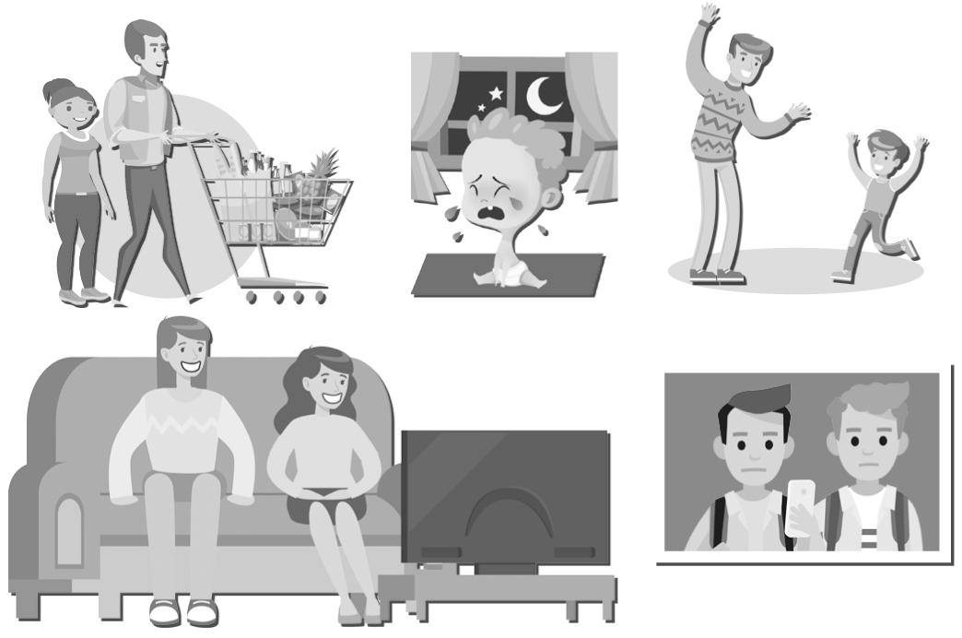
1
2
3
4
5
1
2
3
4
5

