VOCABULARY
1 Choose the correct answer.
1 Eve is very friendly. Everyone thinks she is charming / messy / skilful.
2 My teacher was very reliable / proud / hopeful of me because I got 100% in my English test.
3 Sandy is a skilful / an anxious / a nasty gymnast. I love watching her perform.
4 Bill is a cheerful / pleasant / curious person. He enjoys learning new things.
5 Liz is sincere / predictable / hopeful about winning the swimming competition.
6 James finished the project early because he was ridiculous / efficient / courageous.
2 Complete the sentences with the words below.
courageous  anxious  sincere  ridiculous  neat
1 Jenny worries about everything. She’s a very ............................................... person.
2 Jane means what she says. She is ............................................... .
3 My mum organised my clothes in my cupboard. Now it’s very ............................................... .
4 Danny can’t wear those pink trousers. They’re ............................................... !
5 The man saved the mother and the baby from the fire. He was very ............................................... .
3 Match the situations in A to the adjectives in B.
A B
1 He’s happy today. ..... a nasty
2 She’s saying horrible things about people. ..... b selfish
3 He always stops and says hello to his neighbours. ..... c reliable
4 She always says the same things. ..... d cheerful
5 He never helps anyone. ..... e messy
6 Her dirty clothes are all over the house. ..... f pleasant
7 He’s never late. ..... g predictable
grammar
4 Three students rated their personalities for a survey (5 = the most). Look at the results.
Then complete the sentences about the students. Use the comparative or superlative form
of the adjectives in brackets.
 | Ellen | Anne | Bob
cheerful | 12345 | 12345 | 12345
neat | 12345 | 12345 | 12345
curious | 12345 | 12345 | 12345
brave | 12345 | 12345 | 12345
reliable | 12345 | 12345 | 12345
1 ............................................... is ............................................... (cheerful) student.
2 ............................................... is ............................................... (neat) Ellen.
3 ............................................... is ............................................... (curious) Anne.
4 ............................................... is ............................................... (brave) student.
5 ............................................... is ............................................... (reliable) Bob.
6 ............................................... is ............................................... (brave) Ellen.
7 ............................................... is ............................................... (reliable) student.
8 ............................................... is ............................................... (neat) student.
5 Write a new sentence about each pair of teens. Use (not) as … as and the adjectives below.
popular  honest  generous  efficient  young  heavy
1 Dan weighs 60 kilos. Charles weighs 70 kilos.

2 Susan is 16 years old. Linda is 18 years old.

3 Claire and Emma have got many friends.

4 Andrew and Laura always finish their work on time.

5 Peter doesn’t usually share his sweets. Alice always shares with her friends.

6 Karen and Wendy always tell the truth.

VOCABULARY
1 Match the sentences to the pictures in the story below. Pay attention to
the words in bold.
1 She tries to fight the monster.
2 She runs away.
3 A monster approaches a girl.
4 The girl screams.
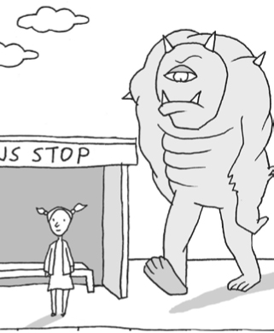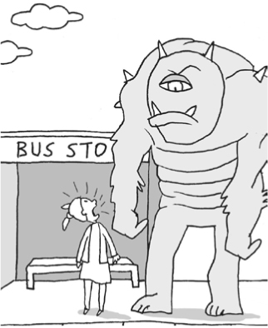
a
b
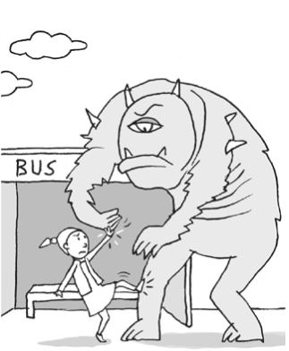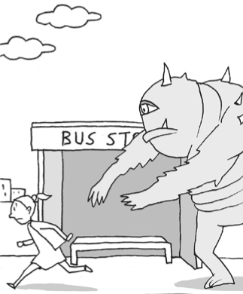
c
d
2 Match A to B to make phrases.
A B
1 wonder ..... a yourself
2 avoid ..... b from the werewolf
3 make a noise ..... c a dangerous animal
4 step back ..... d how to do it
5 defend ..... e late at night
3 Complete the sentences with the words below.
defend  run away  fights  kept quiet  fainted
1 Katy didn’t drink enough during the marathon and she ............................................... after 15 km.
2 We ............................................... and didn’t scream on the scary amusement park ride.
3 Dan should learn how to ............................................... himself when he’s in danger.
4 Peter Pan ............................................... Captain Hook in the classic children’s story.
5 Some animals are scared of humans, so they ............................................... when people approach them.
3
grammar
4 Complete the sentences with too … and the adjectives below.
expensive  frightening  noisy  difficult  dark
1 I don’t understand this article. It’s ............................................... .
2 I don’t go to the cinema very often. It’s ............................................... .
3 You can’t see the people in the picture. It’s ............................................... .
4 She can’t sleep after she watches horror films. They’re ............................................... .
5 Please talk quietly. You’re ............................................... !
5 Match the sentences in A and B. Then complete the sentences in B with (not) … enough and
the adjectives in brackets.
A
1 Don’t ask Anne and Paul for help.
2 She can be an explorer.
3 Marge can’t sing in public.
4 Can Dave design our website?
5 I don’t think Carrie can organise the party.
B
..... a She’s ............................................... (confident).
..... b Is he ............................................... (skilful)?
..... c They are ............................................... (reliable).
..... d She’s ............................................... (efficient).
..... e She’s curious and she is ............................................... (courageous).
6 Complete the second sentence so it means the same as the first sentence. Use the adjectives below and too … or (not) … enough.
predictable  large  tall  weak  old  cold
1 These shoes are too small.
They’re ................................................................. .
2 It isn’t warm enough for a trip to the beach.
It’s ................................................................. .
3 He isn’t strong enough to carry that.
He’s ................................................................. .
4 That actor is too short to play a basketball player.
That actor is ................................................................. .
5 The story isn’t surprising enough.
The story is ................................................................. .
6 Fay is 18, so she can get her driving licence.
Fay is ................................................................. .

