VOCABULARY
1 Look at the family tree and complete the description of Betty and Harry’s family. Use the words below.
grandsons  nieces  husband  granddaughters  son  wife
nephews  daughter
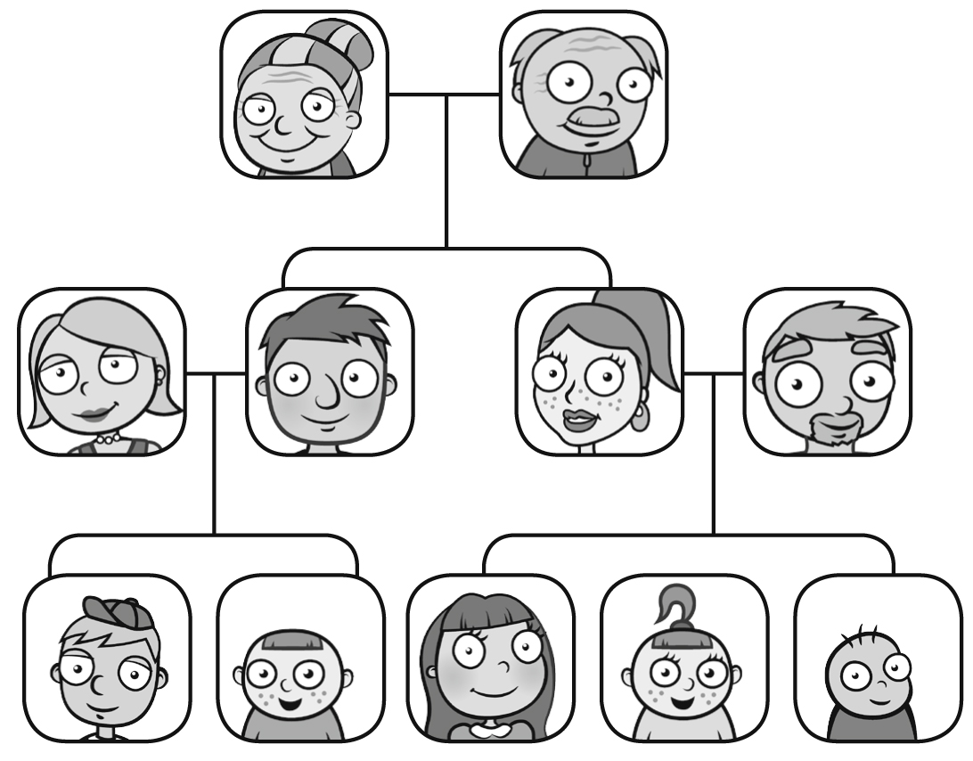
Betty & Harry
Diane & John
Catherine & Chris
Adam Joe
Olivia Kim Annie
Betty and Harry have got two children. They’ve got one ^{1.} ............................................... – John, and one ^{2.} ............................................... – Catherine. Diane is John’s ^{3.} ............................................... and Chris is Catherine’s ^{4.} ............................................... . Betty and Harry have got two ^{5.} ............................................... – Adam and Joe, and three ^{6.} ............................................... – Olivia, Kim and Annie. Adam and Joe are Catherine’s ^{7.} ............................................... . Olivia, Kim and Annie are John’s ^{8.} ............................................... .
2 Find and circle the family words. Then complete the sentences about Lucy’s family with these words.

1 Sally is married to Lucy’s dad. Sally is Lucy’s ............................................... .
2 Lucy is Sally’s ...............................................
3 Lucy’s brother Luke is Sally’s ............................................... .
4 Sally has got a son called Josh. Lucy’s dad is his ............................................... .
5 Sally and Lucy’s dad have got a ............................................... . Her name is Lily.
6 Sally and Lucy’s dad are Lily’s ............................................... .
7 Lucy’s dad’s parents are called Martin and Emily. They are Lucy’s ............................................... .
grammar
3 Choose the correct answer.
1 There were / There was / There wasn’t 30 people in my class last year.
2 There were / There weren’t / There was a long queue in the supermarket.
3 There weren’t / There was / There wasn’t any chocolate in my house.
4 There weren’t / There were / There wasn’t any children in the restaurant.
5 There weren’t / There was / There were a family meal for my birthday yesterday.
4 Complete the questions below. Use Was there or Were there. Then match the questions to
the correct answers.
1 ................................................................ many people on the beach?
2 ................................................................ a restaurant on the beach?
3 ................................................................ a girl playing on the sand?
4 ................................................................ many children in the sea?
5 ................................................................ any chocolate ice cream in the shop?
..... a No, she was in the sea.
..... b Yes, they swam and played in the water.
..... c Yes, many families with little children.
..... d No, they only had vanilla.
..... e Yes, we ate pizza there.
5 Complete the dialogue with the correct form of there was or there were.
1 A: ................................................................ many people at the party last night?
B: Yes, ................................................................ around 25 people there.
2 A: ................................................................ pizza at your grandson’s birthday dinner?
B: No, but ................................................................ hamburgers and chips.
3 A: ................................................................ any interesting programmes on TV last night?
B: Yes, ................................................................ a good documentary about celebrity families.
4 A: ................................................................ any trains after 10.00 pm last night?
B: No, ................................................................ any trains then.
5 A: ................................................................ any food on the aeroplane?
B: No, ................................................................ any food on the aeroplane.

VOCABULARY
1 Find six jobs in the puzzle.
w | x | i | f | j | s | i | n | g | e | r
j | n | n | i | b | i | c | l | a | s | g
f | p | f | r | n | s | l | z | a | e | a
s | a | l | e | s | p | e | r | s | o | n
y | e | r | f | c | e | a | m | u | r | t
b | w | f | i | t | p | n | s | v | p | d
k | z | g | g | q | f | e | b | r | v | r
u | c | e | h | x | i | r | w | e | n | i
r | y | t | t | x | z | v | u | n | w | v
g | x | i | e | d | g | j | v | d | w | e
h | a | i | r | d | r | e | s | s | e | r
2 The words in bold are in the wrong sentences. Write them next to the correct sentences.
1 The artist served us food at the restaurant. ...............................................
2 The businessperson fixed my car yesterday. ...............................................
3 The talented waiter draws beautiful pictures. ...............................................
4 A musician works in a hospital. ...............................................
5 Tim is a mechanic and he plays three instruments. ...............................................
6 A rich nurse bought the company for $1 billion. ...............................................
3 Complete the sentences with the words below.
astronaut  pilot  dentist  author  tour guide  actor
1 Daniel Radcliffe is a British .............................................. . He was in the Harry Potter films.
2 Sam went to the .............................................. yesterday because his tooth hurt.
3 The .............................................. showed us around the city.
4 Neil Armstrong was the first .............................................. to walk on the moon.
5 Bob works as a .............................................. for the airline British Airways.
6 Charles Dickens was a British .............................................. . Two of his famous books are Oliver Twist and
A Tale of Two Cities.
3
grammar
4 Complete the sentences using the correct verb in brackets. Use the Past Simple affirmative.
1 The waiter ............................................... (eat / bring / drink) our food.
2 There was a storm, but the pilot ............................................... (drive / sail / fly) the plane very well.
3 The artist ............................................... (write / paint / read) a beautiful picture.
4 The astronaut ............................................... (build / live / travel) to space last year.
5 The salesperson ............................................... (buy / study / work) in the shop yesterday afternoon.
5 Write sentences with the words below. Use the Past Simple affirmative.
1 the musician / write / a beautiful song

2 my laptop / break / last week

3 the cleaner / clean / the office / yesterday morning

4 I / walk / to the supermarket / an hour ago

5 Kate / see / a funny film / last night

6 Complete the messages below with the verbs in brackets. Use the Past Simple affirmative.
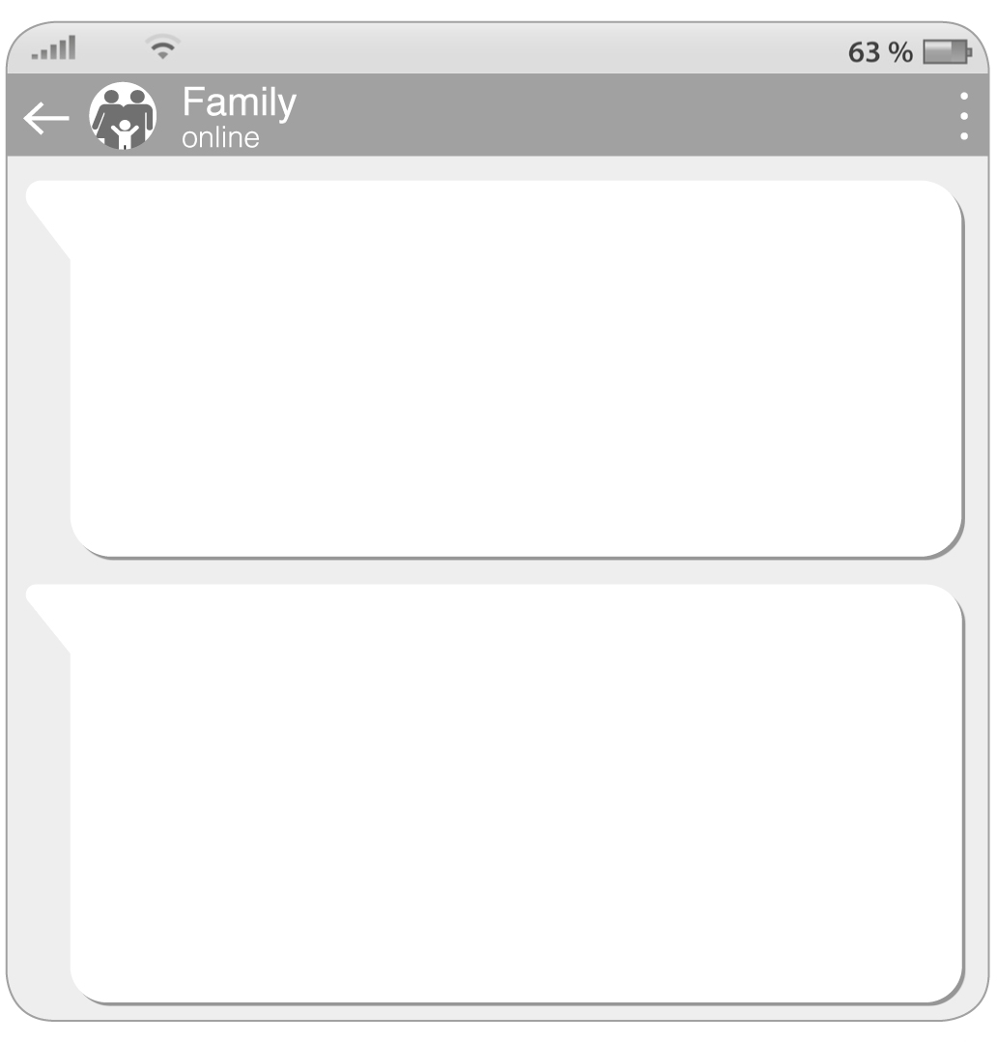
Mum
I ^{1.} ............................................... (buy) you a new jacket.
I ^{2.} ............................................... (get) the last one in the shop!
I also ^{3.} ............................................... (find) your flash drive in the kitchen. I’m going to the cinema now, but don’t worry, I ^{4.} ............................................... (make) chicken for dinner. It’s in the fridge.
Jack
Thanks, Mum. I ^{5.} ............................................... (clean) my room, and I ^{6.} ............................................... (do) my homework. Dad ^{7.} ............................................... (take) the car to the mechanic because there’s a problem with the car, but I’m at home with Annie. She ^{8.} ............................................... (have) a good day at school. See you later! Have
fun at the cinema.

