VOCABULARY
1 Unscramble the words and phrases. Then match them to the pictures.
..... 1 spot gnis .........................................................
..... 2 rabez sorcgins .........................................................
..... 3 neumetsma rakp .........................................................
..... 4 sbu ptos .........................................................
..... 5 ffcrtai hgtli .........................................................
..... 6 unorabdotu .........................................................
..... 7 rca pkar .........................................................
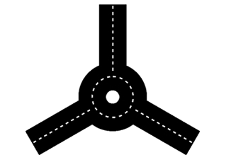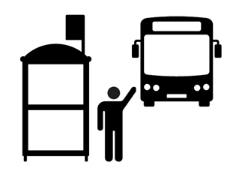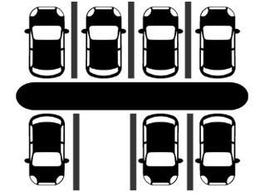
a
b
c
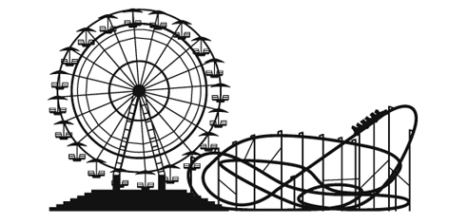
d
e
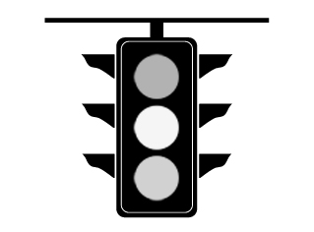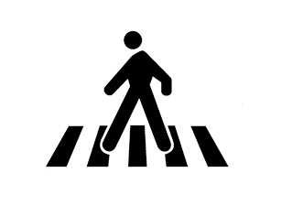
f
g
2 Complete the sentences with the words below.
playground  post office  market  bank  town square  bridge
corner  sights  factory
1 There is a ........................................................ over the river.
2 Children have fun in a ........................................................ .
3 People make cars in a ........................................................ .
4 People often keep their money in a ........................................................ .
5 There are many interesting ........................................................ to see in Prague.
6 There are many restaurants and cafés in the ........................................................ .
7 In the past people went to the ........................................................ to send letters, but today most people send e-mails
and messages.
8 Let’s meet at the ........................................................ of Main Street and Newton Road.
9 They sell fruit and vegetables at the ........................................................ .
grammar
3 Complete the sentences with a, an, some or any.
1 There is ............................................... bridge in San Francisco called the Golden Gate Bridge.
2 Are there ............................................... trains from London to Paris?
3 There is ............................................... amusement park in Barcelona called Tibidabo.
4 There aren’t ............................................... cars on Strøget Street in Copenhagen.
5 There are ............................................... tall buildings in Manhattan.
6 The Louvre is ............................................... museum in Paris.
4 Choose the correct answer.
1 There is some / a / the car park near the bank.
2 Is there a / an / some art gallery in the city?
3 There are much / any / many bus stops near the factory.
4 Are there a / any / the playgrounds nearby?
5 There are some / an / any statues in the town square.
6 A / An / The market isn’t open today.
7 There are a / some / any children in the playground.
8 There isn’t many / much / some fruit in the shop – only apples and bananas.
9 There are a / the / many birds in the trees.
5 Complete the questions with How much or How many. Then answer the questions and make
the answers true for you.
1 ........................................................ students are there in your class?

2 ........................................................ homework do you usually get?

3 ........................................................ bedrooms are there in your house?

4 ........................................................ water do you drink every day?

5 ........................................................ pets have you got?

VOCABULARY
1 Write the activities under the correct pictures.
go camping  go ice skating  see a show  exercise  paint  go bowling
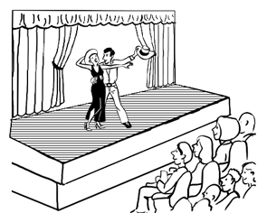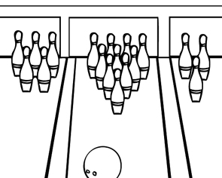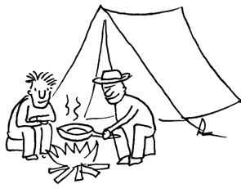
1
2
3
.............................................. .............................................. ..............................................
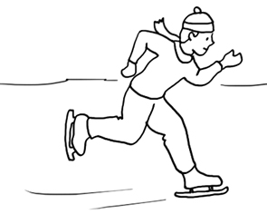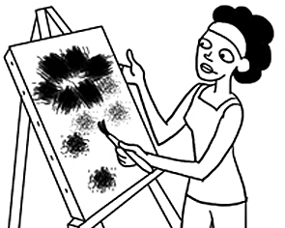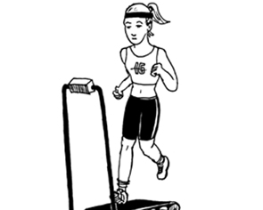
4
5
6
.............................................. .............................................. ..............................................
2 Complete the words in the sentences.
1 Let’s go in that cave and e ..... ..... l ..... ..... e.
2 Do you like to g ..... a ..... r ..... ..... d or do you prefer to travel in your own country?
3 Let’s t ..... k ..... a t ..... ..... p. We can go to the mountains.
4 I don’t like going running alone. I want to j ..... ..... n a g ..... ..... u ..... .
5 Many people t ..... ..... e t ..... ..... r ..... of the different neighbourhoods in Paris every day.
3 Complete the survey questions with the words and phrases below. Then do the survey.
order pizza  go out  hiking  go sightseeing
1Where do you prefer to … with your friends?
ato the cinema
bto the park
cto the beach
2Do you and your family often … ?
aYes. It’s easy and delicious.
bSometimes, but we prefer Chinese food.
cNever! We don’t like it.
3Do you like … ?
aYes, I love walking.
bSometimes, when the weather is good.
cNot really, I prefer to stay indoors.
4What’s your favourite way to … ?
aon a walking tour
bby bike
cby bus
Things You Do
3
grammar
4 Complete the sentences with the verbs in brackets. Use the Present Simple affirmative.
1 My mum usually ............................................... (order) pizza on my birthday.
2 We often ............................................... (explore) cities when we go abroad.
3 Jo never ............................................... (go) camping in the winter.
4 Lara always ............................................... (do) her homework after school.
5 My friends and I ............................................... (play) football on Sundays.
5 Rewrite the sentences using the words in brackets and the Present Simple negative.
1 Jenny paints on Tuesdays and Thursdays. (on Wednesdays)

2 My parents often travel to London. (New York)

3 Dave exercises three times a week. (every day)

4 We often hike near the ocean. (in the mountains)

5 Henry and Janet go abroad in the summer. (in the winter)

6 Write questions using the words below. Use the Present Simple. Then match them to the answers.
1 your grandmother / see a show / every month

2 you / meet friends / at the weekend

3 when / Ben / go bowling

4 what / Mike and Lily / do / every Friday evening

5 your brother / like / going ice skating

..... a on Monday nights.
..... b Yes, she does.
..... c No, he doesn’t.
..... d Yes, I do.
..... e They go to a restaurant.

